Seeds of Fire Fund

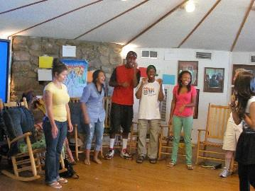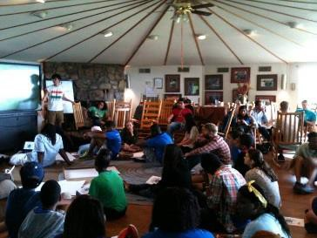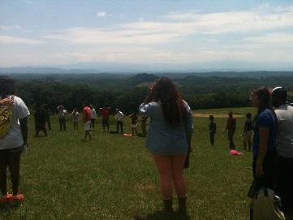

The Seeds of Fire Fund is created by Highlander and supported by the Rockefeller Brothers Fund to support youth and young adult organizing groups and efforts in the South and Appalachia. The fund provides grants to groups that have been engaged with Highlander’s Seeds of Fire program and other intergenerational programs over the past three years to support infrastructure projects under $2,000. You can mail your completed application to:

Seeds of Fire Fund/Kierra Sims
Highlander Research and Education Center
1959 Highlander Way
New Market, TN 37820

Or send the original application and all supporting documents as one file in an email to Kierra
Sims, at kierra@highlandercenter.org. If you have any questions contact Kierra at (865)
850-3333.

Deadline: August 15th Applications must be received at Highlander (not postmarked) by the deadline.

Incomplete applications or applications received after the deadline will not be considered. Highlander is not responsible for late or lost submissions or technical problems that result in late or lost submissions.

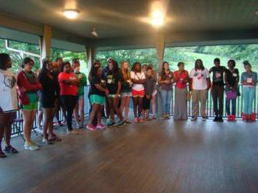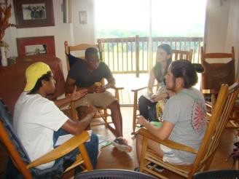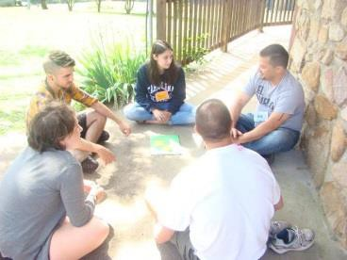If your project is funded, you will be required to acknowledge the Seeds of Fire Fund in literature, programs and advertisements for the funded event or project and to submit a project final report within 30 days of the funded event or project completion. If a final report is not submitted, future applications will not be considered.

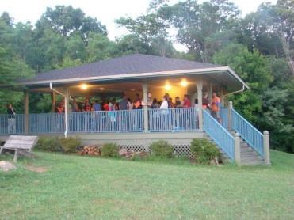

Seeds of Fire Fund Application Form

Name of Organization

Name of Contact Person

Address

City, State, Zip

Phone#_
Fax#

Name of Event / Project:

Amount Requested:
Date of Event / Project:

Please include the following application attachments:

1. Brief Description of the Project (1 to 2 pages)
Please include: location, connection to Highlander aims-be sure to include how the project builds the infrastructure of your group, supports your youth and/or young adult organizing work, the proposed outcome(s), and your qualifications to carry out the project.

2. Project Budget
Show us how the requested funds will be used. Please remember the requested funds should not exceed $2,000. If your project will require support beyond the funding limit of the Seeds of Fire re-granting fund, please state how you intend to obtain additional monies needed. A sample budget is attached. Please also fill out the attached W-9 Form.

3. Reference Letters
Attach three reference letters from individuals or organizations in your community who know of
your organization’s work. References should describe and comment on you or your
organization’s work in the area of youth and young adult organizing and leadership development
and specifically address your organization’s ability to carry out the proposed project.

SAMPLE BUDGETS

Example One:

EXPENSES | AMOUNT | SEEDS OF FIRE REQUEST
Supplies  Stipends  Food for Meetings  Transportation  Total Expenses | $250  $500  $200  $350  $1,300 | $250  $500  $200  $350  $1,300
INCOME | AMOUNT
Seeds of Fire Fund | $1,300

Example Two:

EXPENSES | AMOUNT | SEEDS OF FIRE REQUEST
Rental Equipment  Workshop Materials  Stipends Rental Van Transportation Printing & Postage Fees for Field Trips Website  Total Expenses | $400  $500  $1,000  $300  $250  $350  $75  $150  $3,025 | $400  $1,000  $350  $250  $2,000
INCOME | AMOUNT
Seeds of Fire Fund  Fundraiser (Bake Sale) ABC Foundation  Total Income | $2,000  $500  $1,000  $3,500

Note: You do not have to fill out your budget in this format, if you are currently using a different format. This is only to support those in need of an example.

