

Homecoming 2015

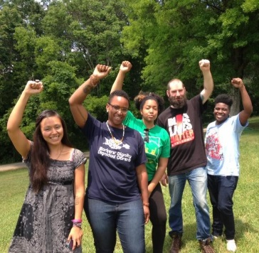
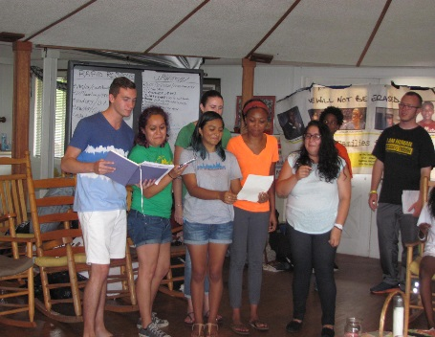
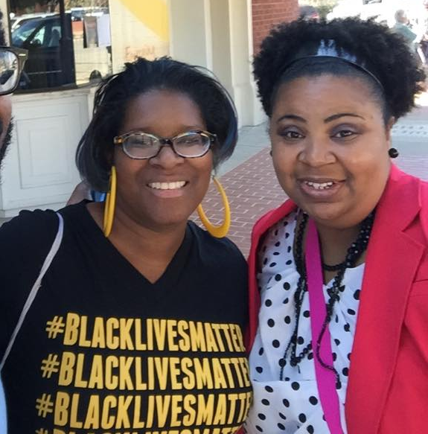
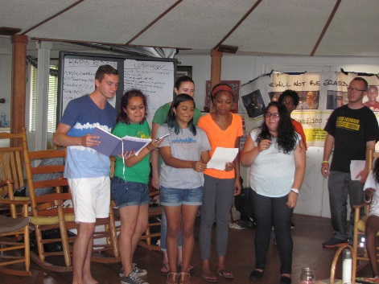
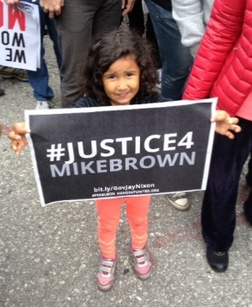
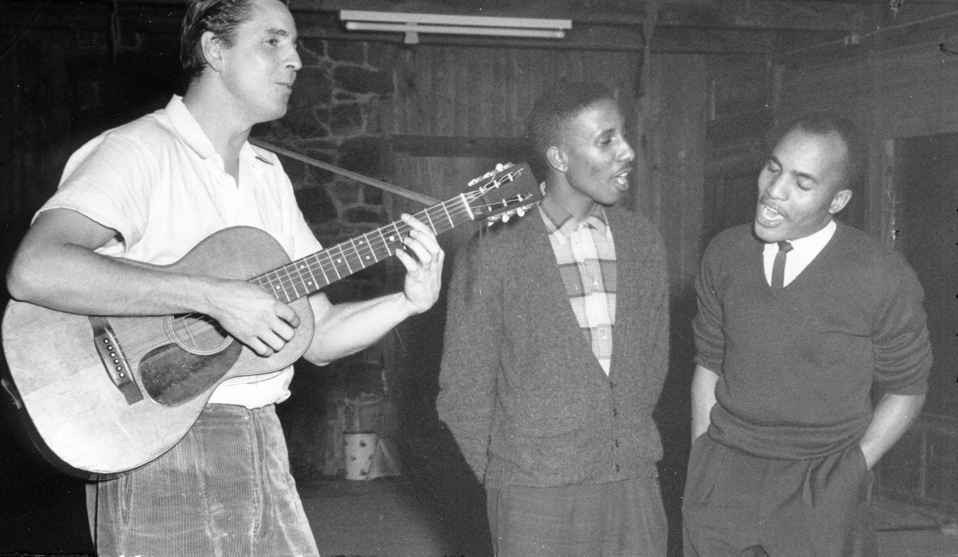
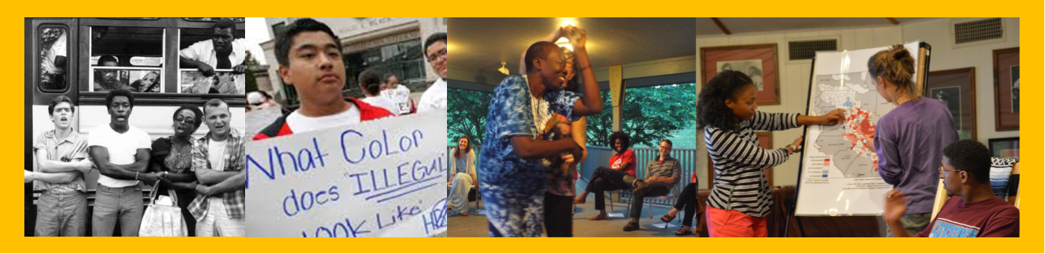

No Longer Erased: Lifting Up
Racial and Gender Justice in Our Homes, Communities, and the Movement
September 25-27, 2015

Highlander Center
New Market, TN

Homecoming 2015 Schedule

Friday, September 25 7:00 – 8:30 pm
A Community Sing Memorial Tribute to Guy Carawan with singers and musicians from the eras of Guy’s life

Pre-Tribute Dinner 5:30 – 6:30 p.m.

Saturday, September 26 10:00 am – 10:00 pm
- Registration opens at 8:00 am

 | Main Tent | Workshop Center | Library/  Resource Center |  | Cultural Pavilion |  | Suite
9 am | Opening Plenary | 9:00 – 9:45:  Orientation / Highlander History and Gender Identity 101 | Registration  Outside |  |  |  | 9:00 – Noon:  Children’s Programming  Children’s Programming
10 am
12 pm | 12:00 – 1:30 pm: Lunch in Dining Room |  | 12:00 – 2:00: Library and Bookstore Open
2 pm | 2:00 – 4:00:  Solidarity Economy Workshop with Jessica Gordon Nembhard, M. Adams, and Esme Baltazar | 2:00– 4:00:  UPSTAIRS:  MAGNet Workshop: Media Justice in Appalachia and the Rural South with MAGNet, William Isom, and Elandria Williams  DINING ROOM:  Power U! Workshop: Black Girls Matter with Power U! and Kierra Sims | 2:00 – 4:00:  Popular Education 101 with Susan Williams and Samir Hazboun |  | 2:00 – 4:45:  Collaborative Art Creation with Charlotte Howard and Mary Espinosa  Acoustic Jam Session / Open to All |  | 2:00 – 4:00:  Children’s Programming
4 pm  5 pm | 4:00 – 4:45:  Free Time for Fellowship  Visit the Video Booth in the Workshop Center to share your Highlander story |  | 4:00 – 4:45: Library and Bookstore  Open |  | 4:00 – 4:45:  Collaborative Art Creation with Charlotte Howard and Mary Espinosa
4 pm  5 pm | Celebration of Highlander's new Lilian Johnson Lodge with excerpt from play by Dr. Sherry Herbers
6 pm | 6:00 – 7:30 pm: Dinner in Dining Room
8 pm to 10pm |  |  |  |  | Dance Party with DJ Nijoli

Sunday, September 27 9:00 am – 1:00 pm
- Registration opens at 8:00 am

 | Main Tent | Workshop Center | Library/  Resource Center | Cultural Pavilion |  | Suite
9 am | Community Sing with April Caddell  Cultural Performances / Community Jam Session with Coy Wakefield, Amelia Parker, Kari Sanders, and Black Atticus | Film Viewing: The Telling Takes Me Home with discussion led by Sue Thrasher | Collective Courage book signing with Dr. Jessica Gordon Nembhard | Collaborative Art Creation with Charlotte Howard and Mary Espinosa |  | 9 am to Noon:  Children’s Programming  Children’s Programming  Children’s Programming
10 am

11:00am

10 am  11:00am | Highlander’s Current Work: A Dialogue with Board and Staff
12 pm to 1 pm | Lunch in the  Dining Room
1 pm | Safe Travels!

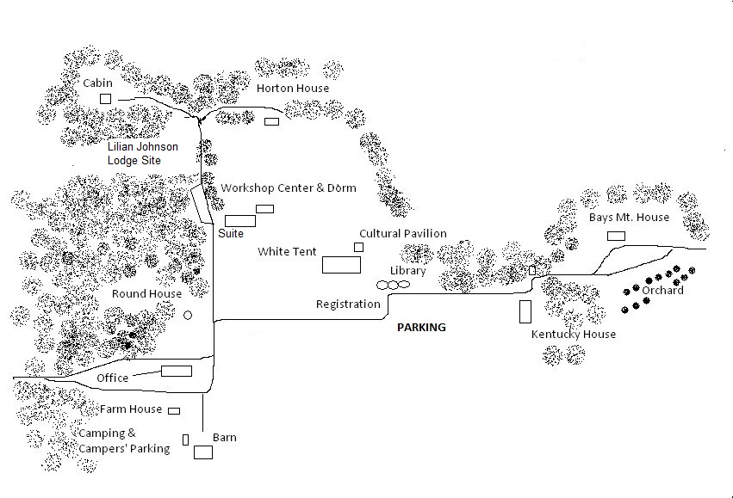
Map
Program Descriptions
Opening Plenary “No Longer Erased: Lifting up Racial and Gender Justice in our Homes, Communities and the Movement”: Highlander Homecoming is a movement-building gathering and a time of great strategies and follow-up actions. We gather this year in the midst of a national movement for Black lives, and our theme lifts up the women, gender non-conforming, and transgendered folks who have been the backbone of this and other historic movements for social justice, and whose experiences all too often are silenced. We will push our understanding of gender beyond the gender binary, and lift up Black women, trans voices, and women across race to examine the current times, and how we get where we need to go. With panelists Dr. Jessica Gordon Nembhard, M Adams, Ash-Lee Henderson, Elandria Williams, Lis-Marie Alvarado, Kendall Bilbrey, Roz Pelles, Betty Garman Robinson, and Esme Baltazar with moderation by Yeshimabeit Milner, Pam McMichael, Allyn Steele, and Kierra Sims, .
Black Girls Matter: Due to structural systems such as- capitalism, patriarchy, and white supremacy- it is easy to think and talk about the effects of State violence on Black people through the lens and plight of Black boys and men. In a movement that is mostly created and led by Black girls and women, Black girls and women voices, stories, and contributions are rarely uplifted first. This workshop will lift up those voices with a discussion on the intersection of race, class, and gender and the importance of this intersectional analysis being at the forefront of the Movement. Join us in uplifting Black women and girls and strategizing ways to take the work back home.
Media Justice Workshop: Ringing from the hills of Appalachia to the halls of Washington D.C.: In 2002, Highlander helped birth the media justice movement. Media justice is a precondition for social justice; without it, movements can't communicate and organize. Through interactive exercises, this workshop will seek surface what media rights, access, and representation issues are needed in the Appalachian region and the country. We will discuss what media justice means, what national and local campaigns are moving right now, and how we can build communication rights for all by collaborating through the Media Action Grassroots Network.
Popular Education - Liberation and Organizing: This workshop will explore participants’ experiences in education, and share Highlander’s ideas around popular education as a core element of organizing for social and economic justice. We will explore how popular education can enrich and enliven participants’ own community organizing and educational work.
Creating a Solidarity Economy: This session is facilitated using popular education and is for everyone, whether or not you consider yourself an expert in the economy. We will collectively define the economy, share our experiences with our current economic system, work together to learn about some solidarity economy examples and envision an economic structure that meets our collective needs. If you are eager to dive into creating a solidarity economy we invite you to join us!

Work with Artists Charlotte Howard and Mary Espinosa: "I Believe We Will Win" is a collaborative mixed media piece that calls upon participants to concretely represent what a win in the fight for racial and gender justice means. The piece will help foster a positive visualization of the work the participants are doing as well as provide a restorative outlet for processing and visualizing wins in the work as a community.

Acoustic Open Jam Session: Bring your instrument and voice to the Cultural Pavilion for music-making and song to accompany our collaborative art project!

Book Signing of Collective Courage: Jessica Gordon Nembhard chronicles African American cooperative business ownership and its place in the movements for Black civil rights and economic equality. Not since W. E. B. Du Bois's 1907 Economic Co-operation Among Negro Americans has there been a full-length, nationwide study of African American cooperatives. Collective Courage extends that story into the twenty-first century. Many of the players are well known in the history of the African American experience: Du Bois, A. Philip Randolph and the Ladies' Auxiliary to the Brotherhood of Sleeping Car Porters, Nannie Helen Burroughs, Fannie Lou Hamer, Ella Jo Baker, George Schuyler and the Young Negroes' Co-operative League, the Nation of Islam, and the Black Panther Party. Adding the cooperative movement to Black history results in a retelling of the African American experience, with an increased understanding of African American collective economic agency and grassroots economic organizing.
Screening and discussion of The Telling Takes Me Home, Produced/Directed by Heather Carawan :
A wonderful film about Guy and Candie Carawan and the importance of music and culture in supporting work for justice! Music and memory tell the story of Guy and Candie Carawan, activists and folk singers who have carried their work from the deep south of the Civil Rights Movement into today's daunting struggle for peace. Interweaving past and present, the filmmaker integrates her own reflections on growing up in a rich musical and political landscape with her parents' views on race relations, community organizing, and the sustaining power of song. This half-hour documentary includes footage from Highlander, where Heather spent most of her childhood. Additionally, the film pays tribute to regional musicians such as Nimrod Workman, Florence Reece, Chuck Neblett, and Matthew Jones. (28:26 minutes, 2005).

Speakers and Presenters

Allyn Steele’s activism started in Northeast Thailand, alongside the Thai people’s movements. He returned to work as an educator-organizer in Spartanburg, SC. As a member of the Educational Network for Global and Grassroots Exchange, he was a participant in Highlander’s 2010 Threads cohort and served as an adult ally for Seeds of Fire youth camp. Allyn holds a B.A. in History from Wofford College and is pursuing a Masters in Divinity at Vanderbilt. He is currently vice-chair of Highlander’s board and becomes chair in November.
Annie Thomas is a Miami native and has been an active freedom fighter in her community since she was twelve years old. During the 2008 presidential election, as a youth member of the Miami Workers Center's Take Back the Vote campaign, she helped register 3000 people to vote and raise community awareness on the importance of organized civic engagement. For the past five years, Annie has served as a leader in the youth organizing work of Power U Center for Social Change and as the youth organizer. This work has centered on fighting the School to Prison Pipeline and advancing Restorative Justice as a means to develop stronger communities both in and outside of the school system. She guided organizing and political education workshops, helped develop language for Trayvon's Law, and along with other leaders met with Governor Rick Scott to discuss the racial justice goals of the protesting youth. Annie graduated from Mavericks High School in the Spring of 2014 and plans to continue her organizing and activism. She hopes to organize young people for public housing and other housing issues affecting the community.
April Caddell is a proud native of Tuskegee, Alabama. She attended workshops at Highlander starting at 14, including Seeds of Fire Youth Camp and the Intergenerational Think Tank. She graduated from Spelman College. After graduation, she served an internship at Highlander and continued as Project Assistant for the Zilphia Horton Cultural Organizing Institute. She is attending University of Alabama, working on her M.A. in Women's Studies.

Ash-Lee Woodard Henderson Regional Organizer Ash-Lee is an Affrilachian (Black Appalachian), working class womyn, born and raised in Southeast Tennessee. She has extensive knowledge of the use of community organizing and is a former staff member of the Chicago SNCC (Student Nonviolent Coordinating Committee) History Project. She is a past member of the United Students Against Sweatshops National Coordinating, Political Education and Collective Liberation Committees. Additionally, she is a long-time activist working around issues of community empowerment, environmental destruction, mountaintop removal mining, and environmental racism in central and southern Appalachia, and has served on the National Council of the Student Environmental Action Coalition. Ash-Lee is a former staff organizer for United Campus Workers, Tennessee’s only union for higher education employees, is a proud member and organizer with Concerned Citizens for Justice in Chattanooga, TN. Ash-Lee is a member of the Movement For Black Lives Organizing Team, is a board member of the Highlander Education and Research Center, and the Regional Organizer at Project South: Institute for the Elimination of Poverty and Genocide based in Atlanta, Georgia.

Betty Garman Robinson is a co-editor of Hands on the Freedom Plow: Personal Accounts of Women in SNCC. During her years with SNCC, (1962-1966) Betty Garman was a leader of the University of California, Berkeley, Friends of SNCC chapter and then for two years a member of the SNCC staff – at the organization’s national office in Atlanta, Georgia, and in Greenwood, Mississippi during Freedom Summer 1964 and later at the Washington SNCC Office. She worked at the Johns Hopkins School of Public Health for 13 years as a researcher on injury prevention and HIV-AIDS studies. In 2003 she was received an Open Society Institute (SOROS) Community Fellowship for a project to popularize the history of social justice organizing in Baltimore and bring organizers together across issues and constituencies. Her most recent work has been supporting grassroots organizations in the fight for racial equity, quality education, worker rights and to defeat a Wal-Mart coming in to Baltimore City. She is currently a member of the Boards of Baltimore Algebra Project and Fusion Partnerships and a member of Baltimore Racial Justice Action as well as Regional Resource person for Showing Up for Racial Justice (SURJ). She is the mother of two daughters and has two grandchildren.

Charlotte Howard is a second year graduate student seeking a Masters of Social Work from the University of Tennessee and is working at the Highlander Center as part of her practice in Social Work. Charlotte is a board member of KnowHow Knoxville, a non-profit working towards youth empowerment. Charlotte is a Knoxville artist specializing in calligraphy, lettering, anatomical art, clay, and representing their experience of bisexuality in the south.

Danielle Chynoweth is the Organizing Director at the Center for Media Justice, home of the Media Action Grassroots Network (MAG-Net). Danielle co-founded the Urbana-Champaign Independent Media Center and lead its purchase of Urbana's downtown post office building for conversion to a media and arts center. At the Prometheus Radio Project, she managed the successful campaign to pass the Local Community Radio Act. She served on Urbana's City Council for 7 years spearheading public arts, wireless, and broadband projects. She has presented on media in Thailand, Burma, and Italy, the United States, and as an Evans Scholar at Evergreen State College. She holds a Masters degree in Political Science from the New School for Social Research and sculpture degree from New College. She is momma to 4 year old Ezra Shine.

Elandria Williams is co-coordinator of the Education Team at the Highlander Research and Education Center and is on the Organizational Leadership Team. She helps coordinate the Southern Grassroots Economies Project and the Economics and Governance Curriculum. She helps support the Appalachian Transition Fellowship Program, our work with The Media Alliance Grassroots Network, the Black Immigration Network and is the former lead for the Seeds of Fire: Youth and Intergenerational Program. She is a lifelong organizer and popular educator starting out as a youth organizer and trainer. She was born, raised and lives in Powell, TN, but her roots and family are in Florida and the Gulf Coast. She is on the board of the Democracy at Work Institute, the U.S. Solidarity Economy Network and the Appalachian Studies Association.

Esmeralda Baltazar co-founded The Crib Collective, a youth-led non-profit in Chicago. Since then, she has worked with the Rural Development Leadership Network in New York, Do Something.org, and Fuerza Unida, a Latina-led organization in her hometown of San Antonio, TX. An accomplished visual artist, Esmeralda also holds an MA in Educational Leadership, Politics and Advocacy from New York University.

Jessica Gordon Nembhard is a political economist and Professor of Community Justice and Social Economic Development in the Africana Studies Department at John Jay College, City University of NY; and author of Collective Courage: A History of African American Cooperative Economic Thought and Practice. She has numerous publications on cooperative economics, community economic development, credit unions, wealth inequality, community wealth, and Black political economy. An affiliate scholar with the Centre for the Study of Co-operatives, University of Saskatchewan, Canada, she is a member of the Grassroots Economic Organizing (GEO) Newsletter and Collective, as well as the US Federation of Worker Cooperatives, the Eastern Conference for Workplace Democracy, the Southern Grassroots Economies Project, The Federation of Southern Cooperatives/Land Assistance Fund, the Association of Cooperative Educators, and the US Solidarity Economy Network. Gordon Nembhard is also a member of the Shared Leadership Team of Organizing Neighborhood Equity (ONE) DC (a community organizing organization in Washington, DC). Jessica is the proud mother of Susan and Stephen, and the grandmother of Stephon and Hugo Nembhard.

Keisha Campbell is from Miami, Florida; her ethnic background is Jamaican. She goes to Miami Norland Senior High School. She is in the 9th grade. She works with many different organizations in her community such as Power U. She works around social justice, LGBTQ rights, gender equality and feminism. She is very passionate about her work and what she does in her community.

Kendall Bilbrey grew up in the Blue Ridge Mountains of Wytheville, Va., and has made it a priority to return to Appalachia-- after having to leave, and create opportunities for young people to stay. Kendall is passionate about the Appalachian region and working towards a just economic transition. Kendall recently completed an Appalachian Transition Fellowship with the Highlander Center where they worked with the Alliance for Appalachia and has served over a year on the Steering Committee of the STAY Project. Kendall is 23 years old and now resides in Whitesburg, KY with their orange dog Melvin serving as the Coordinator for the STAY Project!

Kierra Sims is a member of Highlander’s Education Team. From Spartanburg, South Carolina, she received her Bachelor’s degree from Wofford College, where she later worked as Resident Director. She co-founded Glendale Community Action, organizing and facilitating community meetings, and she was Program Coordinator of the Imagine That Improv Theatre Troupe, working with youth to use improvisational theatre to address social issues.

M. Adams is a community organizer and co-executive director of Freedom Inc., where she has been for seven years. Freedom Inc. works with low to no income Black and Hmong wimmin, queer folks and youth in Dane County. Born and raised in Milwaukee, Adams has been in Madison since 2003. Adams’s dad has been incarcerated most of her life and she comes from a community that has been the extreme targets of police violence. Adams, herself, is also a proud dad to a 2 year old who is a primary motivator for her work. As a queer Black person, Adams has developed and advocated for a strong intersectional approach in numerous important venues: Adams is a leading figure in the Take Back the Land Movement, she presented before the United Nations for the Convention on Eliminating Racial Discrimination, the co-Author of Forward from Ferguson and a work in progress on Black community control over the police, and author to intersectionality theory in Why Killing Unarmed Black folks is a Queer issue. Most recently, Adams can be seen in person, on TV or in the newspapers giving near weekly presentations, testifying and city council meetings, and energizing crowds at protests as a member of the Young, Gifted and Black Coalition

Mary Jose Espinosa is a part of the Education Team as the Seeds of Fire Intern at Highlander Research and Education Center. She is passionate about immigrants’ rights and enjoys learning from and working with young people from across the South in order to work towards our collective liberation. Mary Jose is from Charlotte, NC where she co-founded United 4 the DREAM in 2010, a local immigrant-rights based youth advocacy group.
Pam McMichael is in her eleventh year as Executive Director, coming to Highlander from Louisville, Kentucky. Her organizing and cultural work have focused on connecting people and issues across divides, with key focus on racial justice. She has co-founded local, state, and regional organizations with this core strategy, including Fairness Campaign in Louisville and Southerners on New Ground. She was a national fellow with a Rockefeller Foundation leadership project.
Roz Pelles is the former Director of the Civil, Human and Women’s Rights Department, AFL-CIO, and is currently working with the Moral Mondays/ Moving Forward Together Movement. With a JD from Howard University and a BA in psychology from North Carolina Central University, Roz’s work has been devoted to civil and workers’ rights, and she has served as an advisor in multiple social justice campaigns. Roz served on the board of directors of Interfaith Workers Justice and is also a former Board Chair of the Highlander Center.
Samir Rohlin Hazboun is the newest member of the Highlander Education Team coming on in August of 2015. He primarily works with the Southern Grassroots Economies Project and developing the Economics & Governance curriculum. Prior to Highlander he worked in youth programming. He has a passion for working with co-conspirators to dismantle oppressive systems and move towards a more just world using whatever tools are available.
Sherry Herbers is a native Memphian with a Master's degree in psychology from Memphis State University and a doctorate in adult education from the University of Memphis. When reading Frank Adam's Unearthing Seeds of Fire and John Glenn's Highlander: No Ordinary School, Sherry became intrigued by the woman, another native Memphian, who was the original donor for Highlander. A simple question, "What was her journey" has led to numerous trips to Highlander, to Grundy County, to Wellesley, to Washington, D.C. and to Bradenton, Florida where Dr. Johnson died in 1956. Sherry has written a play, Aunt Lilian's Deed, about the founding and a chapter in Tennessee Women: Their Lives and Times, Volume 2 about the life and contributions of Dr. Lilian Johnson. Along the way, Sherry moved to San Antonio, Texas to teach at the University of the Incarnate Word. She is deeply thankful for their support of her research and for the joy of sharing Dr. Lilian's story with the staff and friends of Highlander.
Shi'kera Carr was born on October 1, 1997, in Miami, Florida. Growing up as a young girl, I was shy and kept myself separated from others. I grew up into a neighborhood with gang violence, homicides, fights, drugs, and people killing one another. Having to be fearful and praying to God that he cover my family and keep us from the dangers that surrounded us in everyday life. I have always been a quiet but open-minded and curious child. I started reading at the age of 4, writing poetry at the age of 10, and dancing at the age of 13. Through my elementary and middle school years I really grew on being able stay focused on my life-long journey to success. My mom became a single parent in the household for 12 years and counting, my dad helps out with making sure we have whatever we need. Now that I am in high school and this is my last year, I have so much effort to put in.
Sue Thrasher is a former member of Highlander’s educational staff who helped organize the Highlander library and collections and also later served on Highlander’s board. She first came to Highlander connected to Freedom Summer as part of a special pilot project of white people working with other white people on racial justice. She was one of the founders of the Southern Students Organizing Committee and a founding member of the Institute for Southern Studies. More recently, she worked at the Five College Consortium in Amherst, MA and has now returned to her hometown, Savannah, Tennessee, which was also the hometown of Myles Horton.
Susan Williams is co-coordinator of the Highlander Education Team and manages the library, bookstore and archive there. She has worked as a community organizer and popular educator for 36 years, tackling environmental and economic justice, immigrant rights, juvenile justice and education issues. She manages the Highlander library and archive, and in interested in developing ways to use the history to inspire current generations.
Will Brummett is the Student Development Coordinator at Carson-Newman University. He joined the Bonner Center family in August 2013. Having grown up in the Jefferson County and the Carson-Newman communities, Will is excited to return to his home region once again. He received his college degree in Religious Studies with minors in Political Science and Nonviolence Studies from Elon University. Before joining the Bonner Center, Will worked two years as an intern with the Kernodle Center for Service Learning and Community Engagement at Elon University, where he oversaw leadership development and outreach efforts for the center. Will’s service interest areas include faith-based activism, community-based education initiatives, grass-root public policy, and environmental justice issues.
William Isom, a native of East Tennessee, is the coordinator of the Community Media Organizing Project, a documentarian and youth mentor at East Tennessee PBS' Smoky Mountain Youth Media. He sits on the board of Clean Water Expected in East Tennessee and works with a regional rural economic development task force. He loves okra and anarchy.
Yeshimabeit Milner is a native of Brooklyn, New York and was raised in Miami, Florida where she first encountered the injustices of structural inequality in school and joined Power U Center for Social Change as a high school organizer on the front lines of the movement to end the school to prison pipeline and build the political power of poor young people of color. Committed to movement building as a vehicle for creating and sustaining large scale social change, Yeshimabeit went on to organize against foreclosures in West Oakland, CA with Just Cause/ Causa Justa while training with the School of Unity and Liberation (SOUL) and worked to continue to advance the movement for education justice nationally.
Yeshimabeit is now a Field Organizer at the Praxis Project after returning to Power U in 2013 to lead a victorious campaign to ban the distribution and endorsement of infant formula in the nation’s largest public hospital as part of The Praxis Project’s Communities Creating Healthy Environments initiative. Yeshimabeit graduated from Brown University with a Bachelor of Arts in Africana Studies with a disciplinary focus in Public Health with highest honors in May of 2012. Yeshimabeit currently serves as the Chair of Education Committee on the Board of Directors for the Highlander Center.

Thank you to our wonderful musician friends who joined us to celebrate and remember the life and music of Guy Carawan: Evan Carawan, Danny Gammon, John McCutcheon, Cathy Fink and Marcy Marxer, Carpetbag Theater, Baldemar Velasquez, Rolando Revilla and Johnny Vasquez, Sparky and Rhonda Rucker, Chuck Neblett, George Reynolds, Frank Reynolds, Ron Short and Joan Boyd, Rich Kirby, and Steve Horton.

Save the Date for
Wild & Wacky, Witty & Wonderful Workshop Week #8!
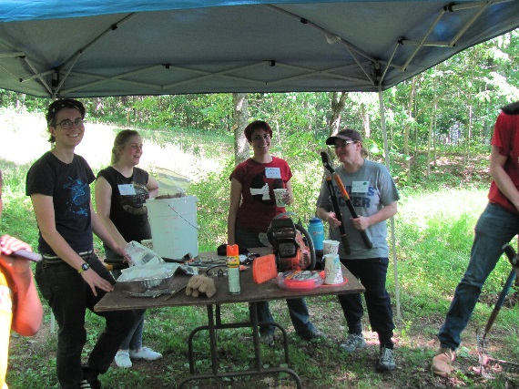
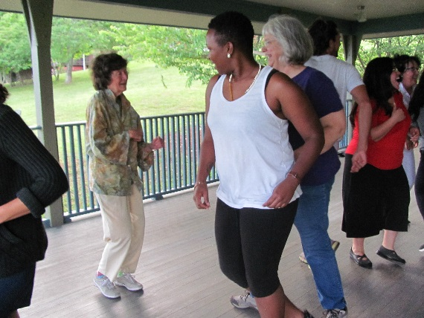
May 31 - June 4, 2016

Email susan@highlandercenter.org for info

Highlander Staff and Board of Directors

Staff:
Johnny Bailey
Esmeralda Baltazar
Andre Canty
Ritchie Carr
Thomas Coward
Tony Denton
Dennie Fisher
Tracey Gilbert
Samir Hazboun
Betty Hickman
Stephanie McAninch
Pam McMichael
Barbara Mott
Kierra Sims
Isis Tafari
Coy Wakefield
Elandria Williams
Elizabeth Wright
Will Wilson
Susan Williams

Interns:
Mary Espinosa
Charlotte Howard

Consultants:
Melody Reeves

Board of Directors:
Henry Allen
Leslie Etienne
Ash-Lee Woodward Henderson
Kara Keeling
Diana Marie Lee
Leslie Lowe
Meizhu Lui
Meta Mendel-Reyes
Yeshimabeit Milner
Margo Okazawa-Rey
Roy Silver
Erica Smiley
Patricia St. Onge
Allyn Steele
Maggie West
Ed Whitfield
Hollis Watkins, Emeritus

Special and huge thanks to all our wonderful volunteers,
especially Peggy Chandler, Sheila Evans, Carol Nickle, and Laurel Panella

Our thanks to the following for their generous support as Solidarity Partners:



Friends & Neighbors:
AAA Taxi
Seal Heat & Air

Contact Us!

1959 Highlander Way
New Market, TN 37890
Web: www.highlandercenter.org
Phone: 865-933-3443
Email: hrec@highlandercenter.org

Printed in-house at Highlander Research and Education Center

